| **""** | **HANDS-ON LAB** Observe States of Matter |
| --- | --- |

You will observe the shape of a solid and liquid in different containers. You will also investigate how the volume of a solid, liquid, and gas may change.

## Materials

* marbles, 16 mm (3), in clear plastic cup
* needleless plastic syringe with cap, 10 mL, disposable
* water in clear plastic cup

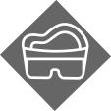 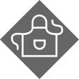

## Procedure and Analysis

**STEP 1** Draw 10 mL of air into the syringe. Record the initial volume in the table below.

**STEP 2** Tighten the cap onto the end of the syringe, if one is available. Alternatively, you can press your finger against the end of the syringe to act as a cap. Push in the plunger. Record the final volume and any other observations.   
SAFETY NOTE: Always point the tip safely away from others when pushing in the plunger.

**STEP 3** Observe the shape of the marbles in the cup. Remove the plunger and place the marbles in the syringe. Then replace the plunger so the bottom of the plunger touches the top of the marbles. Record the volume and observations.

**STEP 4** Tighten the cap. Push in the plunger. Record the volume and observations.

**STEP 5** Observe the shape of the water in the cup. Remove the marbles from the syringe and replace the plunger. Then draw 10 mL of water into the syringe. Record the volume and observations.

**STEP 6** Tighten the cap. Push in the plunger. Record the volume and observations.

|  | **Observations** | | |
| --- | --- | --- | --- |
|  | **Gas (air)** | **Solid (marbles)** | **Liquid (water)** |
| Initial shape | not visible |  |  |
| Shape in syringe |  |  |  |
| Initial volume |  |  |  |
| Final volume |  |  |  |
| Additional observations |  |  |  |

**STEP 7** **Do the Math** How much did the volume of the samples change when you pushed in the plunger? Based on your results for the volume of air, what might you conclude about the shape of air in the syringe? Explain.

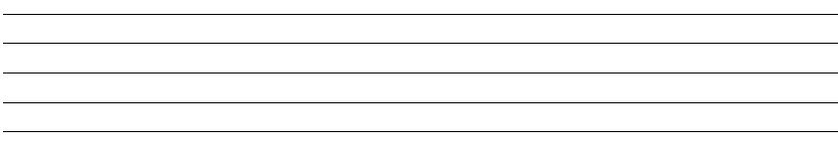

**STEP 8** Which patterns did you observe that help to classify any matter as a solid, liquid, or gas? Compare the observations that you made for the solid, liquid, and gas samples of matter. Write **can** or **cannot** to make each statement true.

Gases Blank space change shape and Blank space change volume.

Liquids Blank space change shape and Blank space change volume.

Solids Blank space change shape and Blank space change volume.